**Project 2:**

Deploying a web server in Ubuntu instance.

Step 1: Create Ubuntu instance using AMI: Ubuntu Server 20.04 LTS (HVM), SSD Volume Type

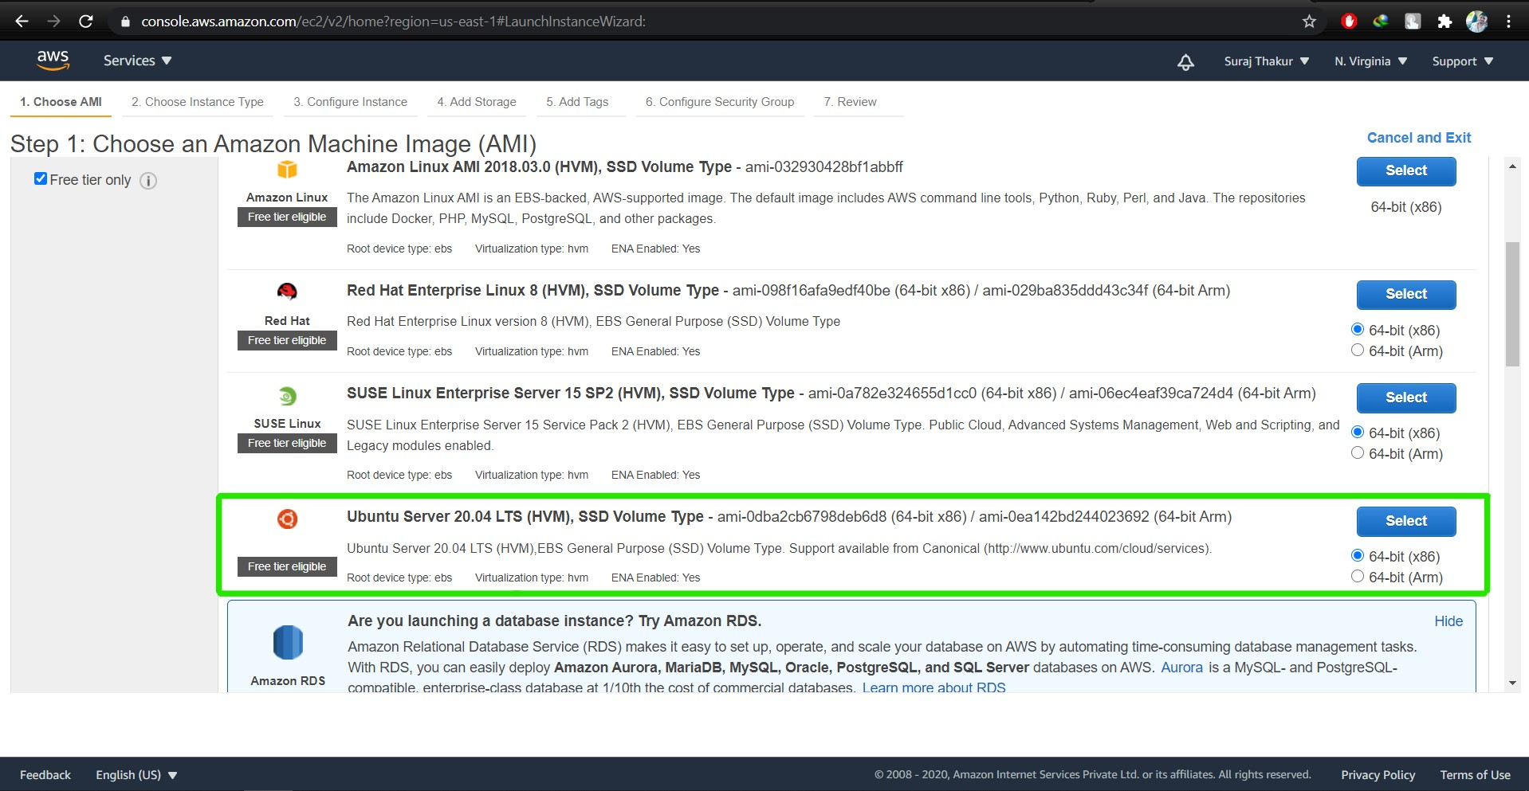

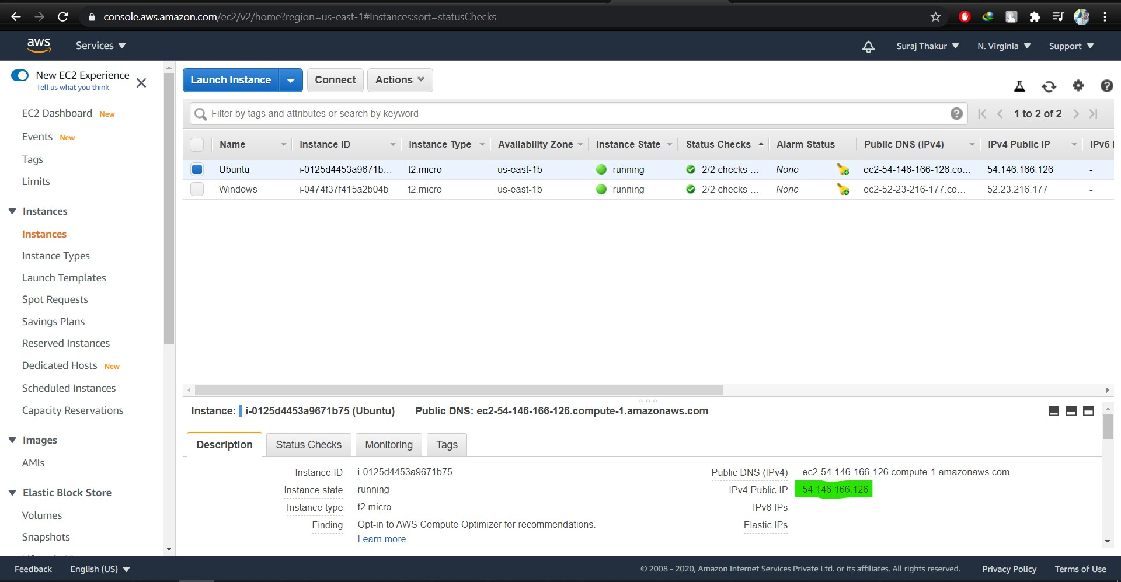

Step 2: Lauch the Ubuntu instance using SSH

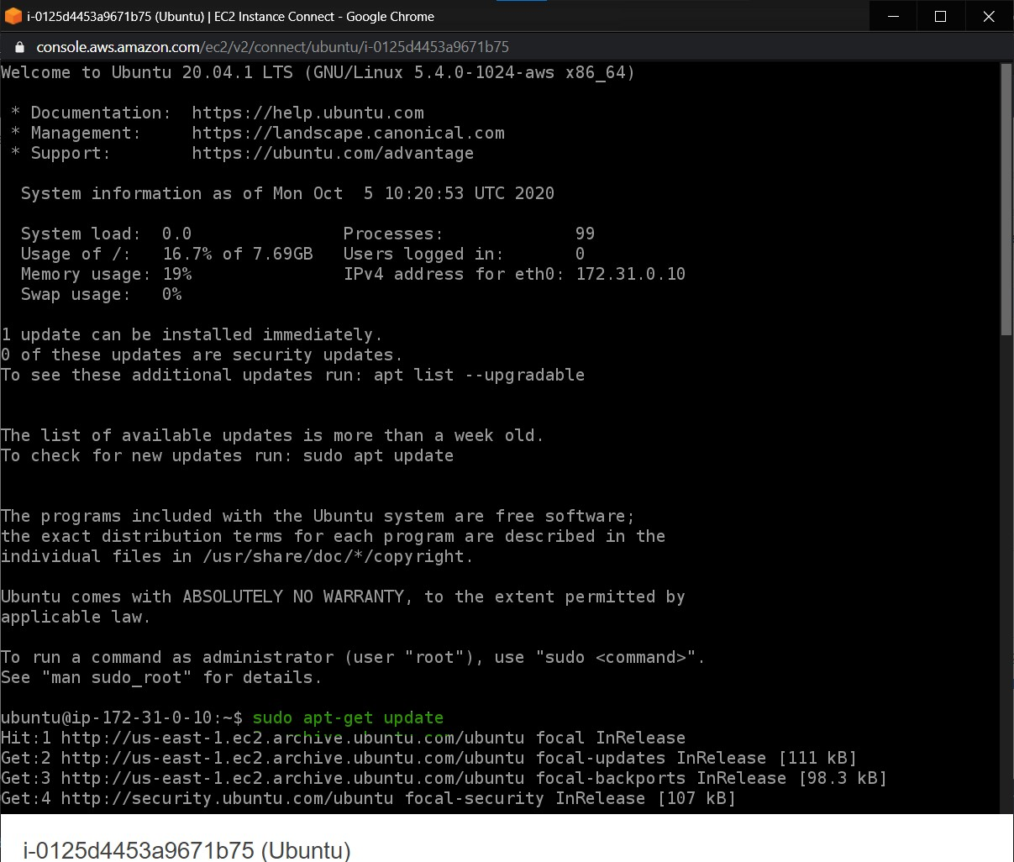

Step 3: Install nginx using following command:

**sudo apt-get update**

**Sudo apt-get install nginx**



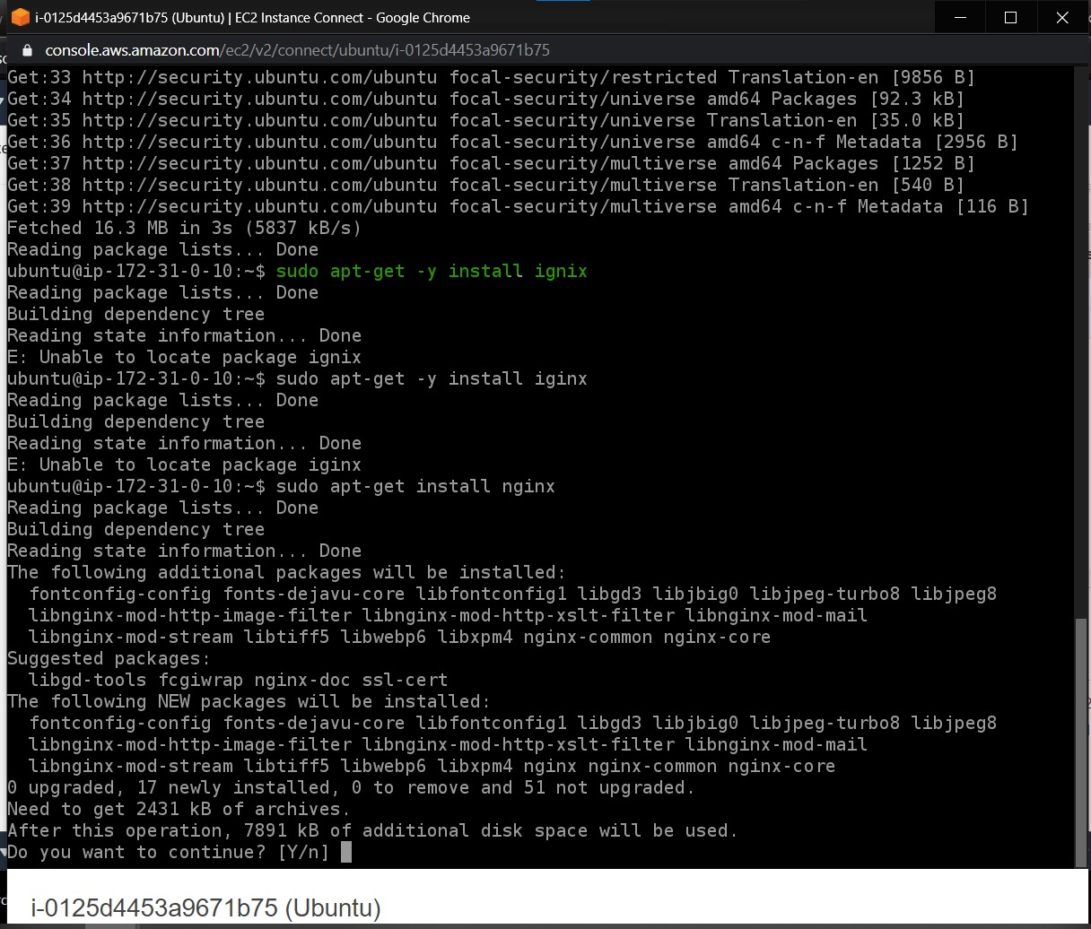

Step 4: Verify successful installation of nginx

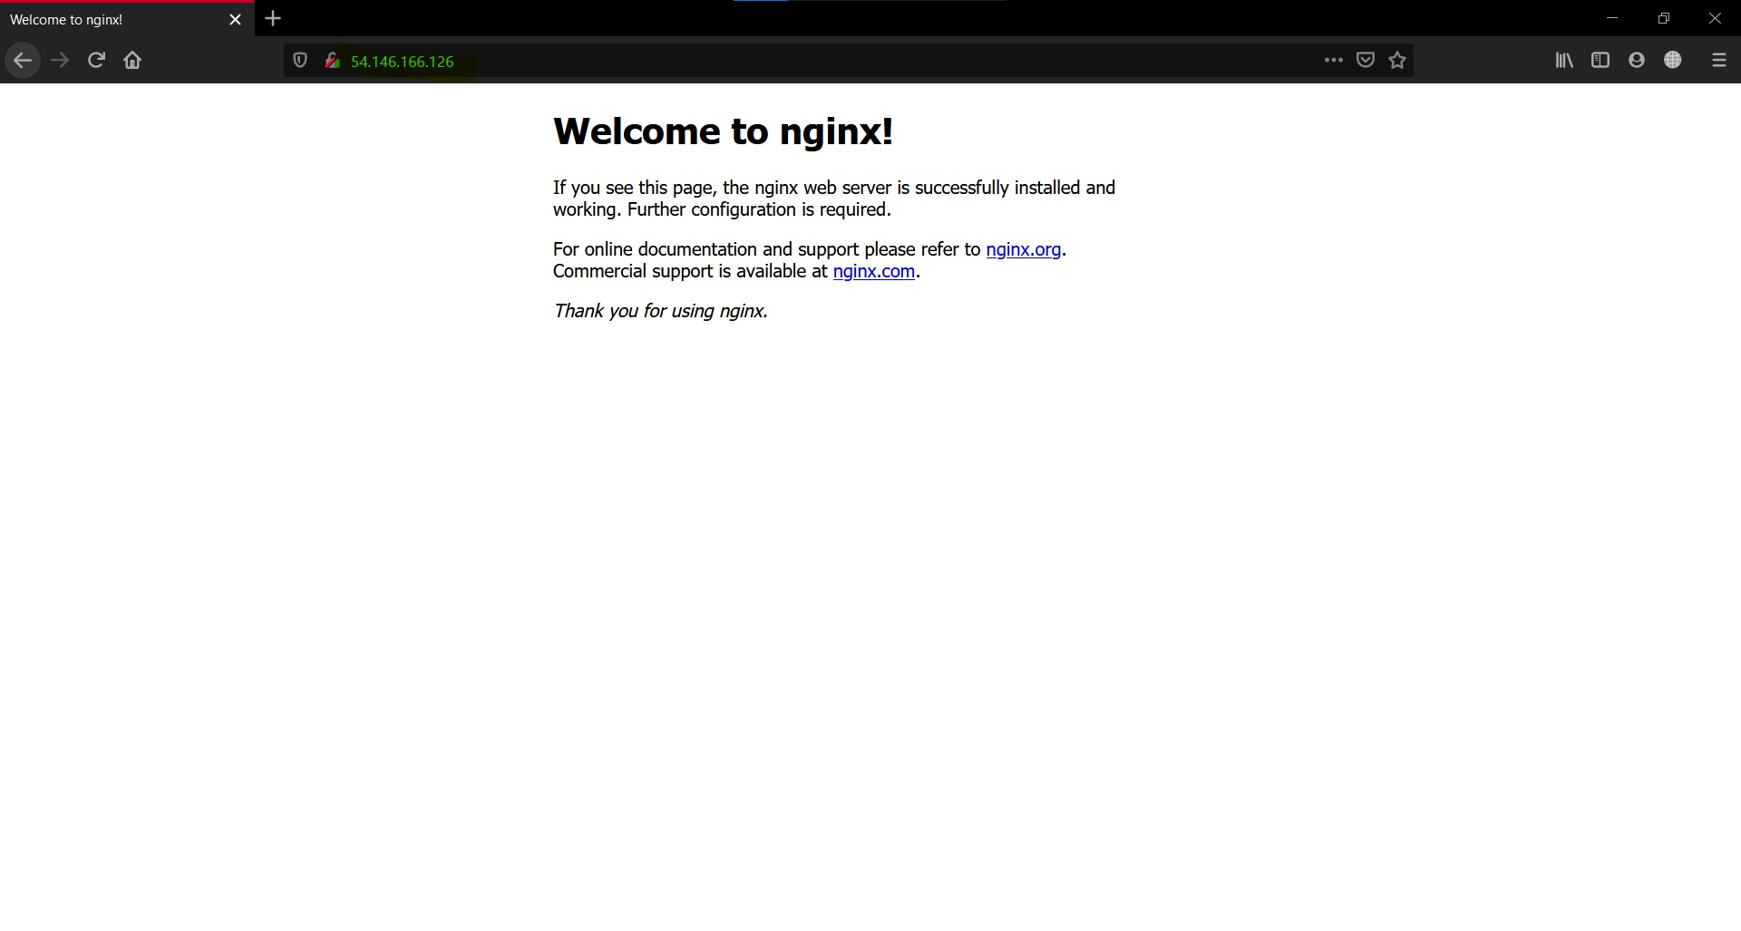

Note : You should be able to see “Welcome to nginx” webpage when you paste the public IP into the browser.